Harvey Norman Account Login

Created by – Pramod Gopisetty

Version No - 1.0

Date – 23rd October, 2016

Approval:

|  |  |  |  |
| --- | --- | --- | --- |
| Position | Name | Comment | Signoff |
| Project Manager |  |  |  |
| Developer |  |  |  |
| Client |  |  |  |
| DBA |  |  |  |

**Index**

1.0 Introduction 4

2.0 Business Objective 4

3.0 Business Process 5

3.1 Activity Diagram 5

3.2 Account tab creation 6

3.3 Account Page Wireframes 7

3.4 Existing Customers login 8

3.5 New customers Account creation 10

4.0 Login Screen explained in detail 11

4.1 Email Address Field 11

4.1.1 Rules 11

4.1.2 Error Messages 12

4.2 Password Field 12

4.2.1 Rules 12

4.2.2 Error Messages 12

5.0 Create an Account Page explained in detail 13

5.1 First Name 13

5.1.1 Rules 13

5.1.2 Error Messages 13

5.2 Last Name 13

5.2.1 Rules 13

5.2.2 Error Messages 14

5.3 Email address field in accounts creation page 14

5.3.1 Rules 14

5.3.2 Error Messages 14

5.4 Set up a Password 14

5.4.1 Rules 15

5.4.2 Error Messages 15

6.0 Flow chart 16

Figure Index 17

References 18

# 1.0 Introduction

The aim is to create an online shopping website for Harvey Norman. As an initial stage, we need to create an Account Creation page which allows new customers to register and shop online. Once logged in, the customer has the ability to browse the products online and can also purchase them by paying online.

The Accounts tab on the home page of their website, should lead to the Login/Account Creation Page. Customers can use their Email address to register for an online account. After registering, the customers can use their Email address to login to their Harvey Norman account. The customers can also login to the Harvey Norman website using their Facebook account.

# 2.0 Business Objective

Harvey Norman is a large Australian-based, multi-national retailer of furniture, bedding, computers, communications and consumer electrical products.[1]

They now want to start marketing their products online and allow their customers to buy their products online. In order for the customers to shop online, they need to have an active online account with Harvey Norman. If they don’t have an existing account, they can register for an online account in the same website.

The main objective of this Project is to create an Accounts page, where the customer either can login to their ‘My Account’ using their existing credentials or can register for an new online account with Harvey Norman.

Email address and Password do have specific conditions to meet. The site will direct its customers to the next screen if both the username and password of that customer matches. New customers should register using the ‘Create and Account’ link on the same page. When the customer clicks on the Create an Account link, the system should direct them to another page where the customer enters the Email address and can setup Password. After the customer enters this information, a validation Email is sent to the customers email address. When the customer clicks on the validation link in their Email, the link should direct them back to the Harvey Norman Login page where the customer enters the Email address and Password to be able to go into the customers ‘My Accounts’ Page.

# 3.0 Business Process

## 3.1 Activity Diagram

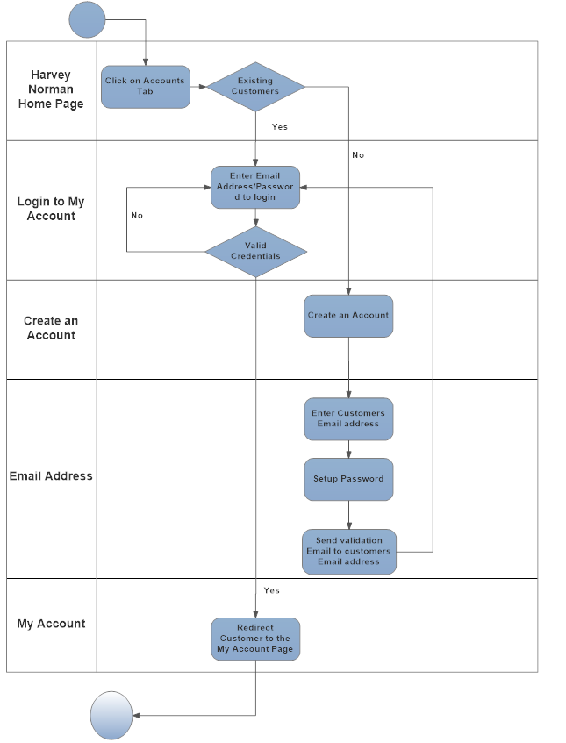

Figure – Flow chart

## 3.2 Account tab

On the homescreen of the Harvey Norman website, an ‘Account’ tab should be created between the 2 existing tabs – ‘Catalogues’ and ‘Contact us’. The background color, font size is the same as the other tabs.

This Account tab should be a link that should direct the customers to the new page.

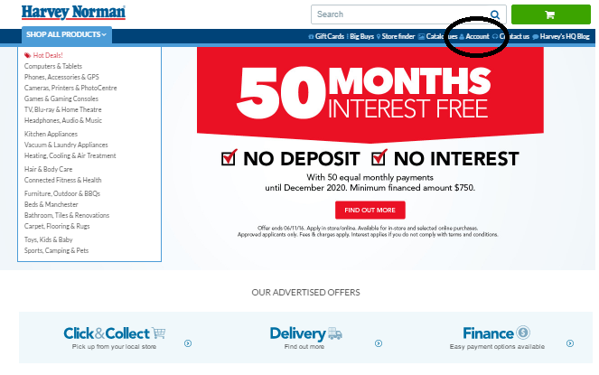

Figure 2 – Harvey Norman Home Page

## 3.3 Account Page Wireframes

When the customer clicks on this ‘Account’ tab, the system should direct them to the Login/Account Creation Page.

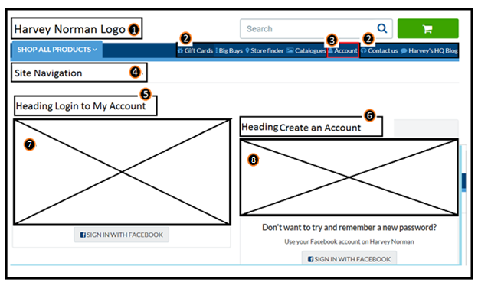

Figure 3 – Wireframes for Accounts Page

1. Harvey Norman Main Logo – The dimensions and format of this logo is same as the all through this website
2. Existing Tabs – Allows customers to navigate freely to different tabs
3. New tab to be created with the title – Account
4. Site Navigation – Allows customer to the home page.
5. Heading for the Existing customers login section
6. Heading for the New customers account creation section
7. Existing customers login section
8. New customers accounts creation section

## 3.4 Existing Customers login

The login section (Ref – 7 in Figure 3), should have 2 fields for customer to enter – Email address field and Password Field.

Below these 2 fields, there should be 2 buttons – ‘Login’ and ‘Forgot your password?’. After the customer enters valid Email address and Password, they can click on the Login button that will direct them to the ‘My Accounts’ Page.

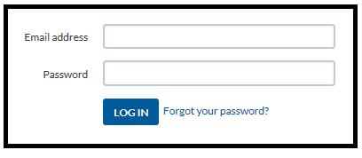

System navigate to below screen

Figure 4 – Login Section

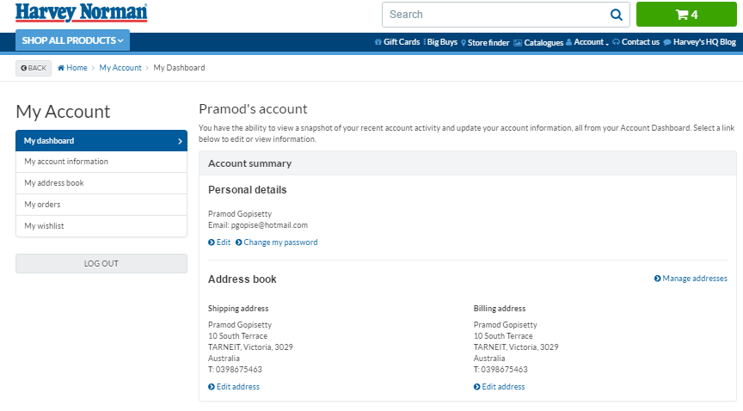

Figure 5 – Customer Accounts Page

## Forgot your Password

If the customers cannot recollect their password, they can use the Forgot my Password link which is present next to the ‘Login’ button.

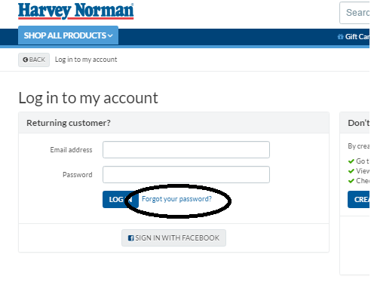

Figure 6 – Login Section

After they click on this link, system should display email address field and submit button as shown in below screen.

The rules and error messages for this Email address field are exactly the same as the main Email address field.

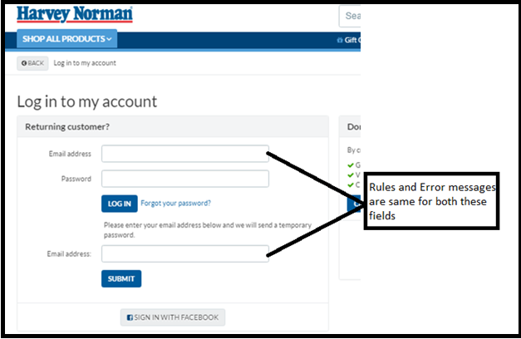

Figure 7 – Forgot Password screen

Once customer enters there email address an clicks on ‘Submit’ button a temporary password is sent to their email address. Using this temporary password, they can login to their account and can later on change the password from the ‘Account’ page.

## 3.5 New customers account creation process

New customers, who wish to register with Harvey Norman, should click on the **‘Create an Account’** button in the Account creation section (Ref – 7 in Figure 3).

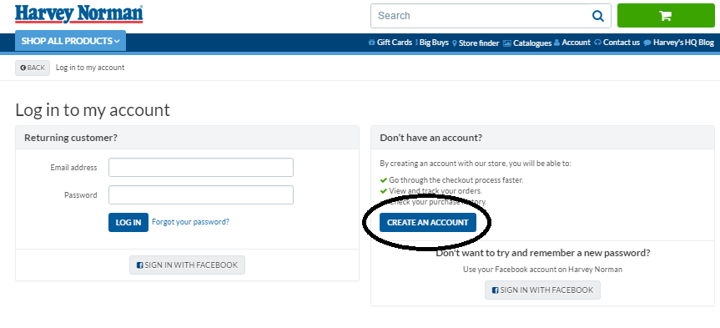

Figure 8 – Create Account Page for new customers

This will lead the customer to a new page, where the customer needs to enter their information to sign up.

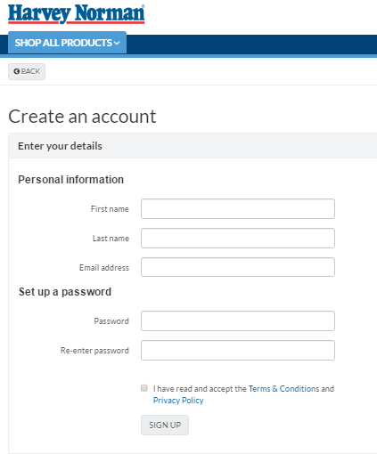

Figure 9 – New customer Account creation Page

Once they enter all the details and set up a password, the customers should tick the Terms & Conditions and Privacy Policy to sign up.

# 4.0 Login Screen explained in detail

## 4.1 Email Address Field

If a customer is having a valid account with Harvey Norman, they can directly login using their Email address and start shopping. They should enter this in the Email address field.

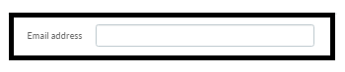

### 4.1.1 Rules

1. Email address field cannot be blank.
2. Email address field should contain a valid Email address.
3. The system shouldn’t allow the customer to enter the Password if they enter incorrect username.

### 

### 4.1.2 Error Messages

1. If the Email address field is not entered or left blank – an error message under ‘Email address’ field – ‘***Please enter your Email address’*** should come up.
2. If Email address is not entered in the correct format and error message – ‘***Please enter a valid email address’*** should come up under the Email address field.
3. If the domain doesn’t exist – an error message under ‘Email address’ field – ‘***Please enter your Email address’*** should come up.

## 4.2 Password Field

After the customer enters a valid Email address, they now need to enter their password in the Password field.

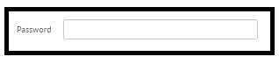

### 4.2.1 Rules

1. The system should authenticate the customer, only when the customer enters the right combination of their Email address and Password.
2. Password cannot be blank. Password should have a minimum of 1 uppercase letter and 1 lowercase letter.
3. Should have alteast one number. Size cannot be more than 6 characters.

### 4.2.2 Error Messages

1. If a customer enters the incorrect combination of Email address and Password, an error message – ‘***Please enter a valid email address and Password. Contact us if you need help’*** should come up at the top below the Log into my account section.
2. If the password field is left blank and the customer tries to login, an error message stating – ‘***Please enter your password’*** should come up below the Password field.

# 5.0 Create an Account Page explained in detail

## 5.1 First Name

The customer enters their first name in this field.

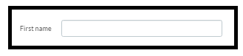

### 5.1.1 Rules

1. The maximum string size for this field is 10 characters.
2. The minimum size is 3 characters.
3. This field cannot be numbers or special characters and should only be alphabets.
4. This field cannot be blank.

### 5.1.2 Error Messages

1. If the customer enters less than 3 characters or if they enter more than 10 characters and error message stating – ***‘First name can be only between 3 and 10 characters’*** should come up below the First name field.
2. If the customer enters any other characters other than alphabets and error message stating – ***‘First name can only contain alphabets’*** should come up below the First name field.
3. If the customer leaves the First name field blank and if they try to login, and error message stating – ***‘First name cannot be blank’*** should come up below the First name field.

## 5.2 Last Name

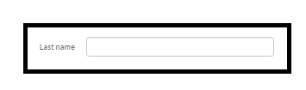The customer enters their last name in this field.

## 5.2.1 Rules

1. The maximum string size for this field is 10 characters.
2. The minimum size is 3 characters.
3. This field cannot be numbers or special characters and should only be alphabets.
4. This field cannot be blank.

### 5.2.2 Error Messages

1. If the customer enters less than 3 characters or if they enter more than 10 characters and error message stating – ***‘Last name can be only between 3 and 10 characters’*** should come up below the Last name field.
2. If the customer enters any other characters other than alphabets and error message stating – ***‘Last name can only contain alphabets’*** should come up below the Last name field.
3. If the customer leaves the Last name field blank and if they try to login, and error message stating – ***‘Last name cannot be blank’*** should come up below the Last name field.

## 5.3 Email address field in accounts creation page

Customer enters their email address. This is the same Email address they use to login to their Harvey Norman Account.

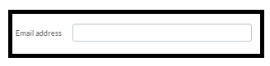

The Rules and error message for this Email address field is the same as the one’s listed under the Login Section.

### 5.3.1 Rules

*Refer 4.1.1 Rules*

### 5.3.2 Error Messages

*Refer 4.1.2 Error Messages*

## 5.4 Set up a Password

The customer needs to set up their password here. They need to enter it twice in order to correctly set up their password.

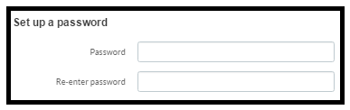

### 5.4.1 Rules

1. Password should be of 6 characters in length.
2. Password should contain a combination of uppercase letters, lowercase letters and numbers.
3. Password field and Re-enter password field cannot be blank.
4. The customer should enter their password twice, while creating their account.
5. Password can only be alphanumeric.

### 5.4.2 Error Messages

1. If a customer enters any other combination other than the rule stated above, and error message stating – *‘****Passwords can be only alphanumeric’*** should come up under the Password field.
2. If a customer does not enter a password and if they leave it blank an error message stating –***‘Passwords cannot be blank’*** should come up under the Password field.
3. If a customer uses different passwords in the Password and Re-enter password field and error message stating – ***‘Please re-enter a password that matches the above field’*** should come up below the Passwords field.

# 6.0 Flow chart

# 

Figure 10 – Flow chart

# Figure Index

Figure 1 – Flow chart 5

Figure 2 – Harvey Norman Home Page 6

Figure 3 – Wireframes for Accounts Page 7

Figure 4 – Login Section 8

Figure 5 – Customer Accounts Page 8

Figure 6 – Login Section 9

Figure 7 – Forgot Password screen 10

Figure 8 – Create Account Page for new customers 10

Figure 9 – New customer Account creation Page 11

Figure 10 – Flow chart 16

# References

1. ["Company Profile"](http://www.harveynormanholdings.com.au/companyprofile.htm). Harvey Norman (Generic Publications Pty Limited). Sited 23rd October, 2016.